**Activity 6**

**Question 1**

Some IT savvy palaeontologist has separated the fun facts about dinosaurs from their names and pronunciations, leaving us to guess which dinosaurs these are:

Query editor Merge data

We don't know what to call it but this dino probably calls you dinner!

Using the CSV and Excel files in the above folder, merge the data together into a new table in your data model. This should look like this:

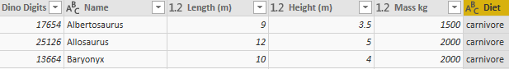

The other columns are still there just off the page (probably too scared to be near these beasts).

Since we have created a new table we don't want to import the duplicated data from our original files. Stop them from loading into the data model:

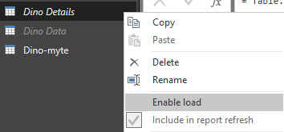

This lets us reference the original files without making our **pbix** file any larger with repeated data.

Optionally save this as **Digging for dinos**, then close it down.

Create a new Power BI report.  Load data from the Excel workbook in the above folder to get:

Initial list

The initial list of websites (we have much to do).

Make the first row the header row and rename and remove columns to get:

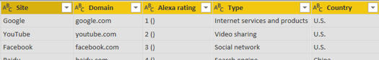

Better - now the fun begins!

Add in a column to number each row, as shown here, and rename the resulting column to **Ranking**:

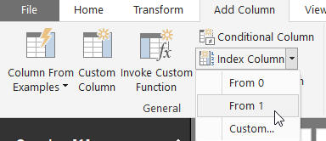

This option effectively numbers each row.

Use splitting columns to derive the current Alexa rank, keeping the number but losing the bit in brackets after it:

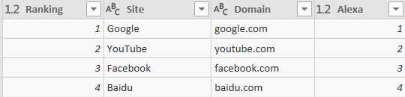

Alexa is an online tool to show how popular websites are (it's by no means 100% reliable). Although the early Alexa numbers are the same as those for the website's ranking, you'll see there are big differences towards the bottom of the list.

Load this data back into Power BI, and use it to create a chart something like this:

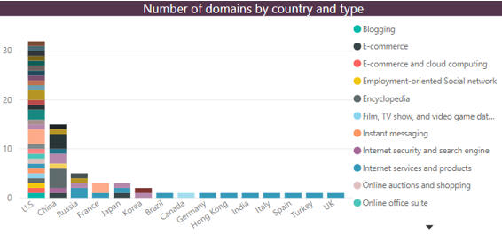

This chart shows how many domains there are for each country and type.

Save this report as **Google rules**, then close it down. **File 489**

Before you can do this exercise, you'll need to download and unzip [this file](https://www.wiseowl.co.uk/files/execise-question-files/qf-480.zip) (if you have any problems doing this, [click here](https://www.wiseowl.co.uk/sundry/exercises-unzipping/) for help).

**Question 2**

Open the Power BI report in the folder above, and create the following report:

Open the Power BI report in the above folder.  The aim of the exercise is as follows:

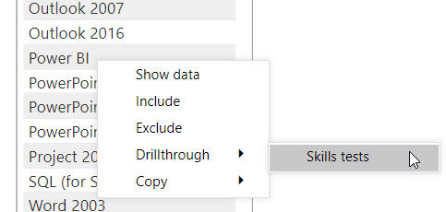

Your aim should be to allow a user to right-click on an exam on the main page, and have this show an analysis of all of the tests taken for this exam on the second (hidden) page.

To do this, apply a drill-through field to the (hidden) **Skill tests** page of the report.  You should then be able to drill through from the **List of exams** page.  Here's what you'd see if you right-click on Power BI and drill through, for example:

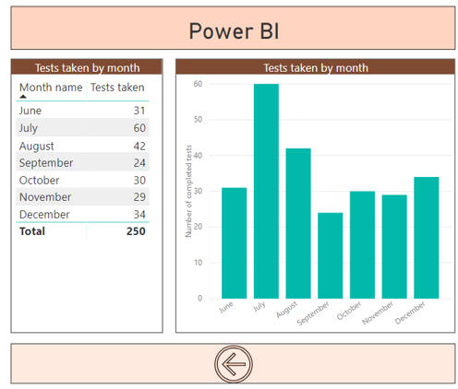

The Power BI test was only published in June 2018. Try moving, resizing and formatting the back button created for you automatically so that it looks as shown above.

Save this report as **Selected tests**, then close it down. 494

**Question 3**

Open the Power BI **pbix** report file in the above folder - it should look like this:

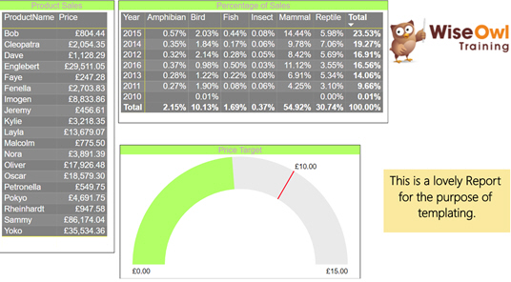

You may need to apply the JSON custom theme included in the above folder to get this exact look.

Before saving the report as a template (the point of this exercise), delete the original dataset to get the following:

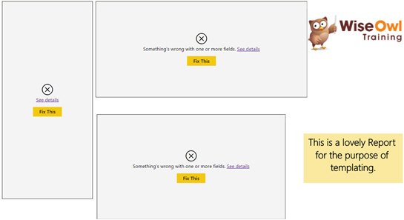

This will appear to have ruined all your hard work, your life and any hope you had at happiness, but not to worry!

It is high time the report became a Power BI template.  To make this happen choose **Export** from the **File** menu:

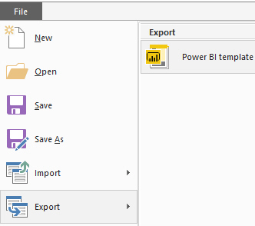

Save the template with the name **Basic template** and add a suitable description.

**Question 4**

Open the template (this will have the effect of creating a new report based upon it).

Use the CSV file in the above folder to repopulate the visuals using different data, and watch as they come to life with interesting facts:

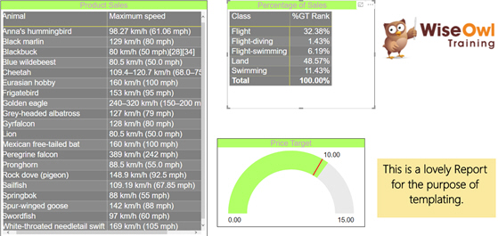

Ok so interesting might not mean compatible, but look how fast that bird is!

Optionally save this as **Temperamental Templates** and close it down. 474

**Question5**

Open the **pbix** file in the above folder. This file contains some calculations and a slicer:

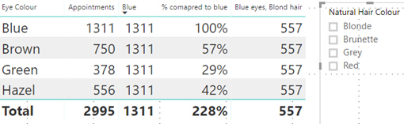

The aim of this exercise is to add a pop-up to explain how to use the slicer.

The easiest way to do this would be using a bookmark, saving the visibility of a textbox, shape and image:

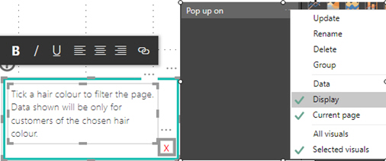

Attach this to a suitable button positioned on the slicer. The help button is good for adding instructions, while the little x is a blank button.

Setting up the hidden side is a bit trickier (and is impossible without using the **Selection Pane**, which can be turned on via the **View** tab):

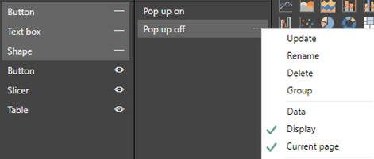

You can use the **Selection Pane** to turn the visibility of visuals on or off: just click the eye symbol next to each. You can rename a visual by changing its title.

Attach this bookmark to the x button on the pop-up. Repeat the process to add information buttons next to the columns in the table:

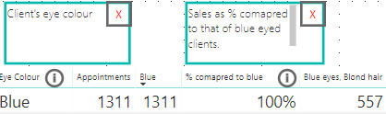

This isn't limited to text boxes. It is possible to have buttons switching chart types, playing music, visiting hyperlinks and loads more!

Optionally save this as **Pop up and say hi** and close it down. 467

**Question 6**

Open the Power BI report in the above folder.  The data shows the number of completed tests by exam for each month of 2018 from the Wise Owl [skills assessment site](https://www.wiseowl.co.uk/power-bi/exercises/power-bi-desktop/charts/skill/):

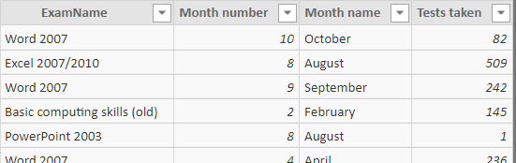

For example, 82 tests were completed for Word in October 2018.

Create a waterfall chart showing for each month the two leading causes of a change in the number of tests taken (with everything else lumped together as **Other**):

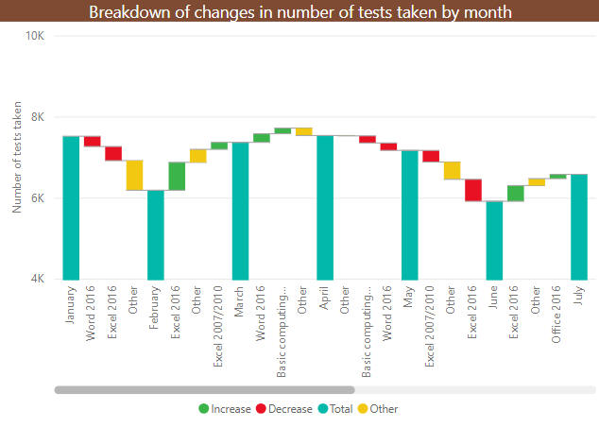

Unsurprisingly, the yellow **Other** category is often the biggest.

Save this report as **May the force be with you**, then close it down.485

**Question 7**

Import both tables from the above workbook.  Power BI Desktop will join them together by the wrong field!

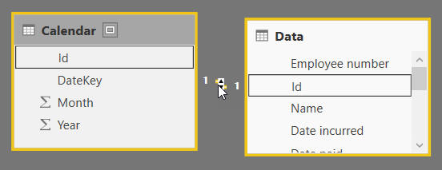

The id field just numbers the rows in each table - it's unfortunate that it happens to have the same name and data type in each table.

Delete this relationship, then import another copy of the calendar table, rename both tables and create relationships to get:

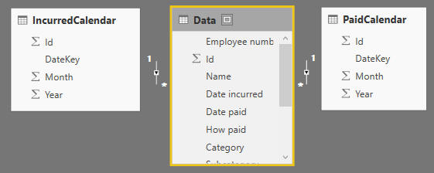

One relationship should use the date an expense was incurred, the other the date an expense was paid.

Use this model to show that a few expenses were incurred in one year and paid in the next:

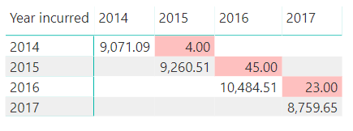

You could apply a conditional formatting rule to highlight numbers less than 100, as here.

Save this file as **Small fry**, then close it down.403

**Question 8**

Create a new Power BI Desktop file, and if you haven't already done so, run the SQL script in the above folder to create a database of Make-a-Mammal data.

From this database load the following tables:

* **tblCentre**
* **tblCentreType**
* **tblPurchase**

Create the following bubble chart!

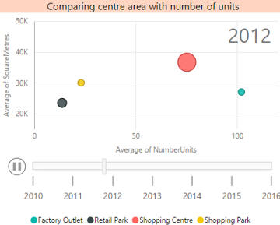

Here we're in the middle of playing the chart - we've reached 2012. The printed page doesn't do justice to the tackiness of the bubbles shooting around the chart!

Save this as **Just bubbles**, then close down the Power BI instance. 280

**Question 9**

Open the Power BI report (not the Excel workbook) in the above folder:

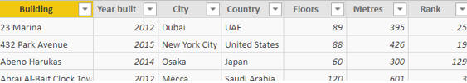

As the text box at the top of the reports says, this contains a list of skyscrapers taken from Wikipedia.

To whet your appetite, create a cheeky card to show the number of skyscrapers:

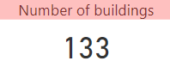

You'll need to turn the **Category Label** off and the **Title** on to get this effect.

Create a bar chart comparing the number of buildings for each country:

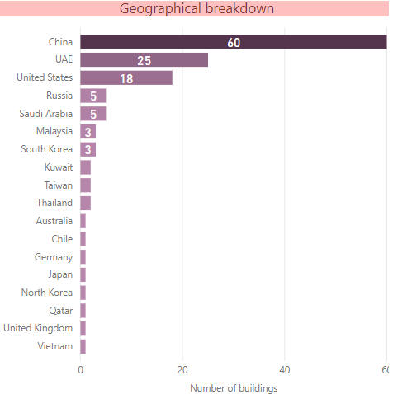

Your chart should show data labels inside the bars, and have conditional formatting to show countries with more skyscrapers in darker colours.

Add the **City** column to the chart and turn on drill mode.  When you click on a bar in the chart you should see a count of the number of skyscrapers for each city in the country you've clicked on:

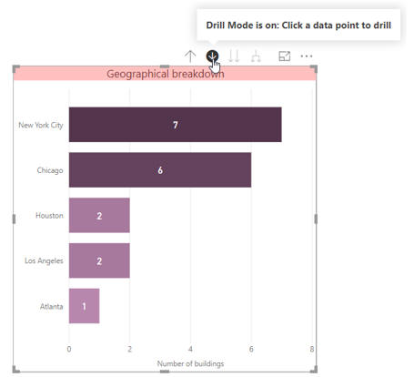

For example, this is what you should see when you click on the **USA** bar.

Save your report as **Symbols of what though**, and close it down.483

**Question 10**

Open the Power BI report in the above folder. It contains 3 pages:

|  |  |
| --- | --- |
| **Page** | **Contents** |
| **Choices** | Empty |
| **By decade** | A chart comparing the number of world events by decade |
| **List of events** | A table listing all of the events in the underlying tables |

On the empty **Choices** page, add the following slicers:

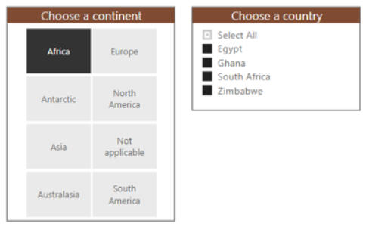

You should be able to choose by continent and/or by country.

Add in a slicer allowing you to choose the event date:

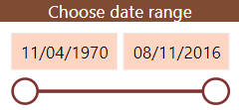

The start and end dates should be set automatically for you.

Using the **Sync slicers** pane, configure your report so that the slicers only appear on the first page, but apply to the other pages:

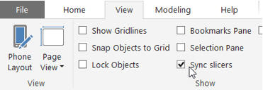

Tick this box to synchronise your slicers.

Check that your filtering works across pages, then save your report as **Synchronicity**, and close it down. 496

**Question 11**

Open the Power BI report in the above folder.  It contains a list of all of the crimes reported in the area around our Manchester training room in 2018:



The area for the reported crimes.

Add a gauge to show the number of crimes with a target (invented!) of 4000 and a range from 0 to 5000:

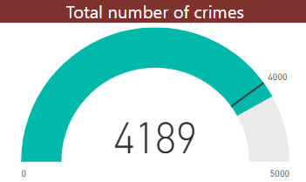

Switch to the formatting properties of the gauge to set an absolute minimum and maximum value.

Now add a KPI to show the number of crimes by month:

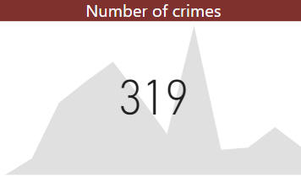

The figure shown is the number of crimes for the final month in the period - for this visual there doesn't seem to be any obvious way of altering the number shown.

Finally, add a column chart comparing crime figures by category and quarter:

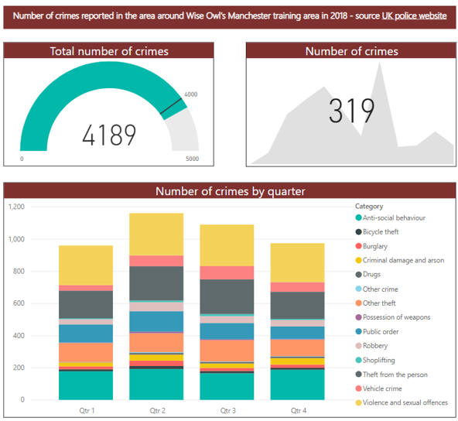

Do stacked column or bar charts actually reveal anything? Wise Owl aren't so sure ...

Save this report as **Reported crime**, and close it down. 484

**Question 12**

Create a new Power BI Desktop file, and import into it the 2015/16 crime statistics in the Excel workbook in the above folder (you can see where the data came from [at this page](https://www.wiseowl.co.uk/sundry/pbd1/), although there are a lot of datasets to choose from there!).

Delete columns in Query Editor so that you're left with these ones:

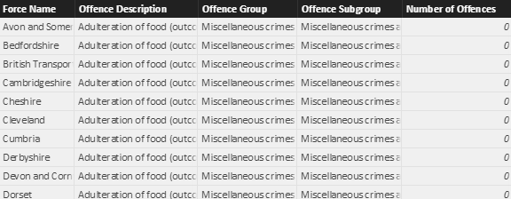

The only columns you'll need for this exercise.

Now create a text box, 3 slicers and a chart to compare the number of crimes for any type of offence across the police forces of England and Wales:

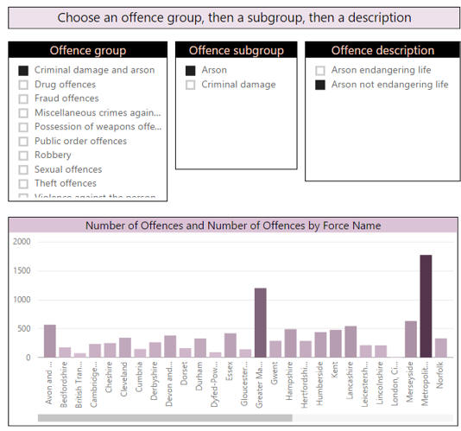

You'll need to make sure child slicers don't affect parent ones, as well as applying colour saturation.

Save this as **Set fire to the brain**, and close down your current instance of Power BI Desktop. 285

**Question 13**

Create a new Power BI Desktop file, and load data from both worksheets in the Excel workbook in the above folder.

In Query Editor, solve this problem:

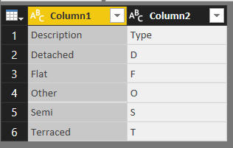

Make the first row of the table into the row headers for it.

Create a relationship between the two tables:

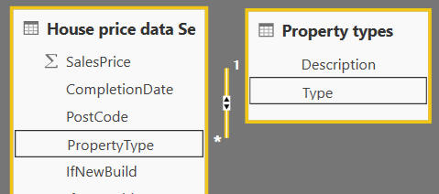

The two tables weren't automatically linked because the field names aren't the same.

Now create a slicer allowing you to show only certain types of houses:287

**Question 14**

Create a new Power BI Desktop, and load data from the Electoral Commission's website.  You can find the link you need at [this page](https://www.wiseowl.co.uk/sundry/pbd1/), or use the Excel workbook in the above folder instead.  Remove a few columns in Query Editor, and create a new one showing the percentage leave vote to give:

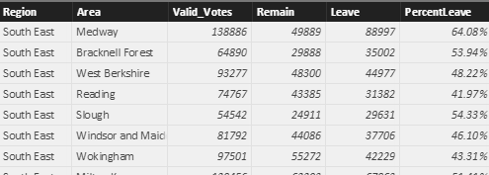

The **PercentLeave** column should equal **Leave** / **Valid_Votes**.

Create a table showing the 10 areas with the highest percentage of votes to leave:

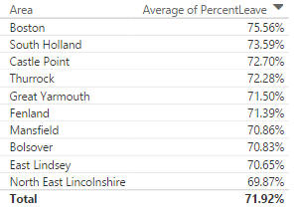

This hasn't got much to do with maps, but it's fun showing how you can analyse real data so easily!

Create as good a map as you can of the percentage leave voters by area:

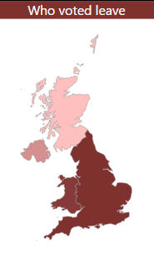

The best that Wise Owl can do. This included enabling the **Shape Map Visual** in Power BI Desktop options, loading the **Regions** workbook from the above folder to associate each region of the country with England, Wales, Scotland or Northern Ireland, and designating the country column to be of data type **Country**.

It would be nice to be able to produce a map of leave voters by region or even area, but maps don't seem to support this.  Unless you can prove differently (quite possible), in which case your trainer would love to hear from you!

Save this file as **Red stains**, then close down the instance of Power BI Desktop containing it. 288

**Question 15**

Create a new Power BI Desktop file.

If you haven't already done so, run the SQL script in the above folder to create a database of Make-a-Mammal data.  From this load the following tables:

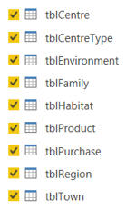

Regular readers might experience a bit of deja vu at this point ...

Create a chart showing sales by region and family:

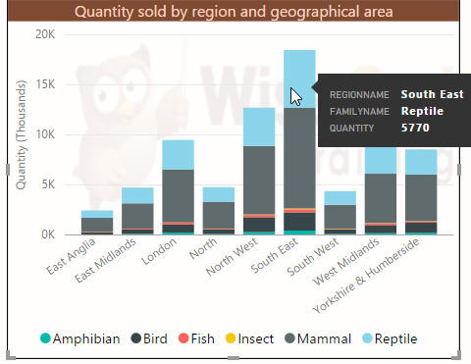

A chart showing total quantity sold by region, for each family. Feel free to download your own image for the background!

Now set drill-down so that when you click on a particular data point (such as the one shown in the previous diagram), you see sales data for that region's towns, and then for that particular town's shopping centres:

|  |  |
| --- | --- |
| Sales by town |  |

Create a gauge, KPI and card to show the quantity of sales:

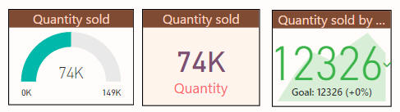

Set the trend axis for the KPI to be the purchase date year.

Remove drill-down, and change your settings so that clicking on a data point filters the gauge and KPI, but leaves the card unaffected:

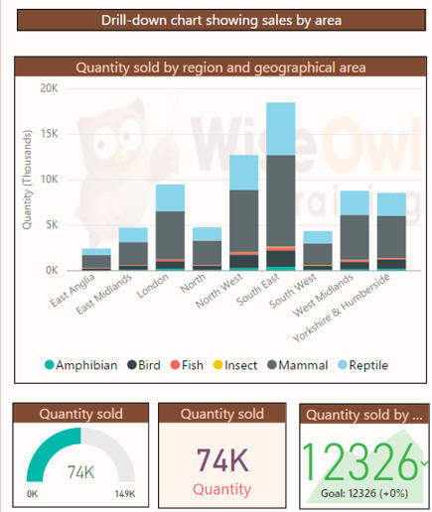

Clicking on the bar for South-East Reptile sales updates the gauge and card, but has no effect on the centre visualisation (the card).

Save this as **Beginning to love PBD**, then close down this instance of Power BI Desktop.280

**Question 16**

Create a new report and load the data in the **First Half.xlsx** workbook.

User Query Editor to tidy up this data so that you have something like this:

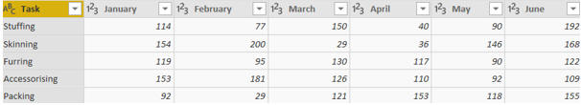

You'll need to remove the top row, then make the new top row into the row headers.

Choose the following option to unpivot the monthly data:

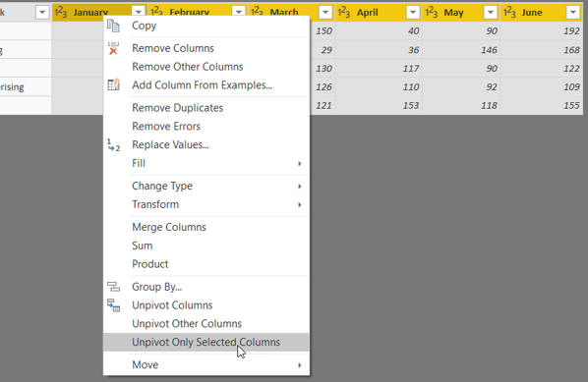

Choose to unpivot the months of data.

After a bit of renaming, you should have this table in Power BI:

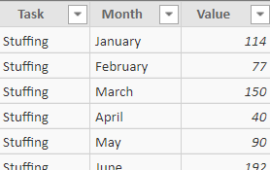

The start of the table of unpivoted data.

Use this to create a chart showing value by month:

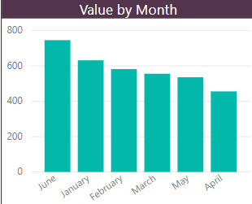

The problem is that we want to sort the months correctly, but to do that you'll need to assign numbers to them.

 Go back to **Query Editor** and add a conditional column:

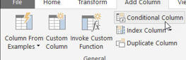

The option to add a conditional column, returning the correct month number for each row.

 This should give you something like this:

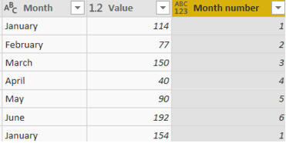

After painstakingly typing in the 6 possible conditions and results, you should have a column turning a month name into a number.

You might have found it easier to do a couple of conditions then edit the M formula for this step to add the other four (it's certainly worth having a look at it to see how easy it is to understand and amend).

You can now choose to sort your month names by number:

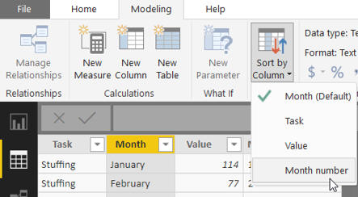

Choose this option to sort your month names correctly.

After checking your chart is sorting by the correct column, you should now have this!

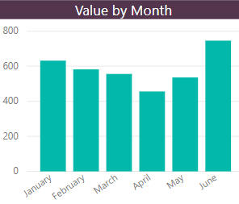

The same chart, but with the correct sort order.

The exercise asked you to link to the wrong file.  Change your M to refer to the file called **Second half.xlsx** (you'll need to go down your query steps making lots of editing changes to resolve errors), then check your chart still works:

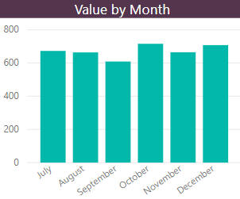

After a lot of retyping in your query step formulae you should eventually get this chart!

Save your report as **The knees of a bee**, then close it down.491

**Question 17**

Create a new Power BI report, and load data from the **Series** worksheet in the Excel workbook in the above folder:

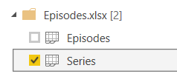

You only need to load this worksheet's data.

Use **Query Editor** to tidy up the Game of Thrones series data:

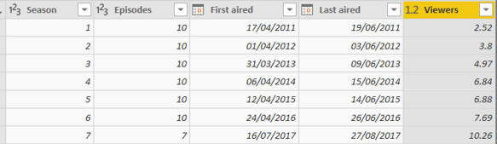

Remove the row which has **TBA** for the number of viewers, remove the extra episodes column and change the data type and name of the viewers column to get something like the above.

Back in Power BI, use the **DATEDIFF** function to work out the difference in days for each series between when it first and last aired:

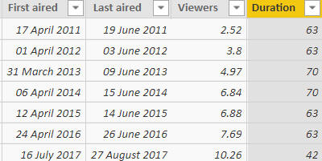

Don't worry about the arguments for the function - Power BI should prompt you to complete them.

Now use an **IF** function to show for each series which category it belongs to using these rules:

|  |  |
| --- | --- |
| **Duration** | **Category** |
| Less than 60 days | **Short** |
| Otherwise | **Long** |

Use this to create a pie chart showing the number of series for each category:

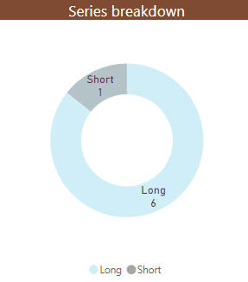

You don't have to add so much formatting - the person doing this exercise obviously had too much time on his or her hands!